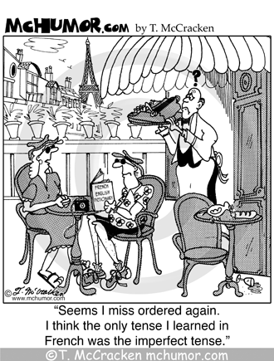**The past tense**

The past simple tense is used to:

* describe something that took place in the past at a specified time

**When to use the present perfect and when to use the past tense.**

The present perfect is used when something happened at an unspecified time in the past.

**I have bought** a new bike. *(open past)*

*The open past begint in het verleden en is nog steeds bezig*

The past tense is used when something happened at a specified time.

**I bought it** last week *(closed past)*

*The closed past begint in het verleden en eindigt in het verleden*

As general rule you can say that if something happened in the past and there is **no clear indication of past time** the present perfect is used.

When there is **a clear indication of past time**, the past tense must be used

The past continuous tense is used:

* to describe something that was going on in the past.

The past continuous refers to a longer action in the past. The past simple refers to a shorter action in the past.

De 2e vorm van de irregular verbs gebruikt een closed past

De 3e vorm (past participle) van de irregular verbs gebruikt een open past